**Keyword Search Algorithm Problem**

**Topics Covered**

1. **Proposed Solution**
2. **Testing Evidence**

**Proposed solution:**

**URL -** [**http://localhost:9997/keywordSearchAlgorithm/**](http://localhost:9997/keywordSearchAlgorithm/)

I have created dynamic web project where user can submit the request from UI and which is further passed to servlet , servlet acknowledge the request and pass the request to appropriate service to perform the business logic and return the result back to servlet which is further pass to UI to displayed the result to end user.

Below is some screenshot of above-mentioned solution.

**OperationControllerServlet.java (Servlet Class)**

Which handle all the request coming from UI.

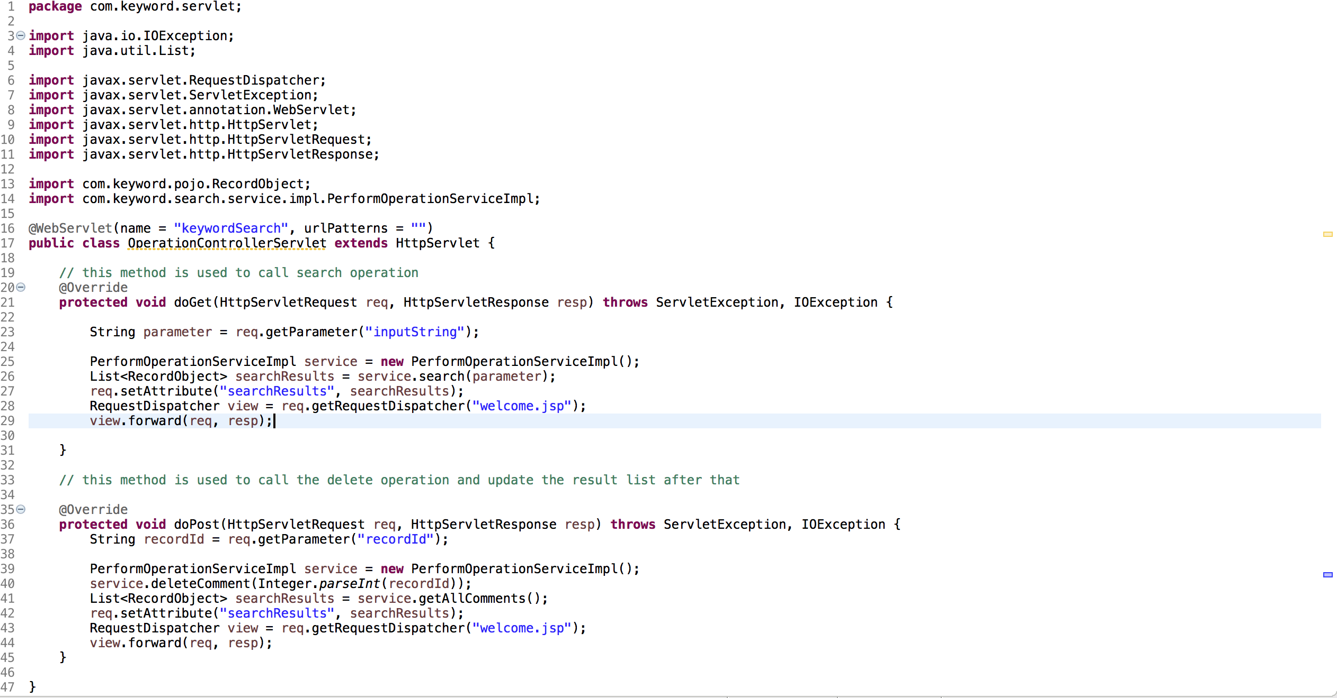

**PerformOperationService.java** (Service Interface)

Service interface class where all the different types of method (operation) defined. (we can extend the functionality or add operations if any)

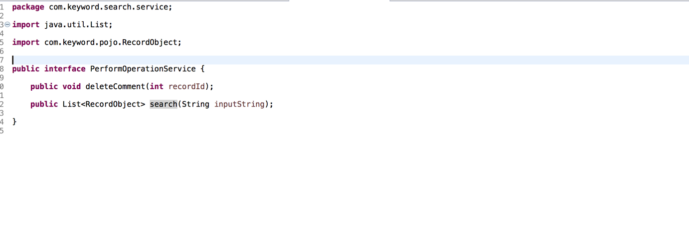

**PerformOperationServiceImpl.java** (Implement the above interface to customize the functionality)

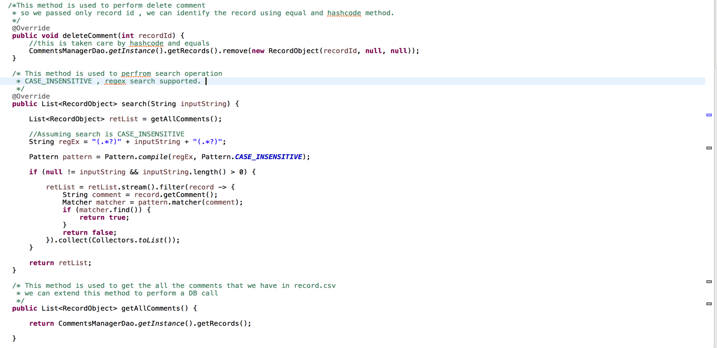

**CommentsManagerDao.java** ( DAO class now we are fetching the data from csv ,we can extend this class to read the data from DB).

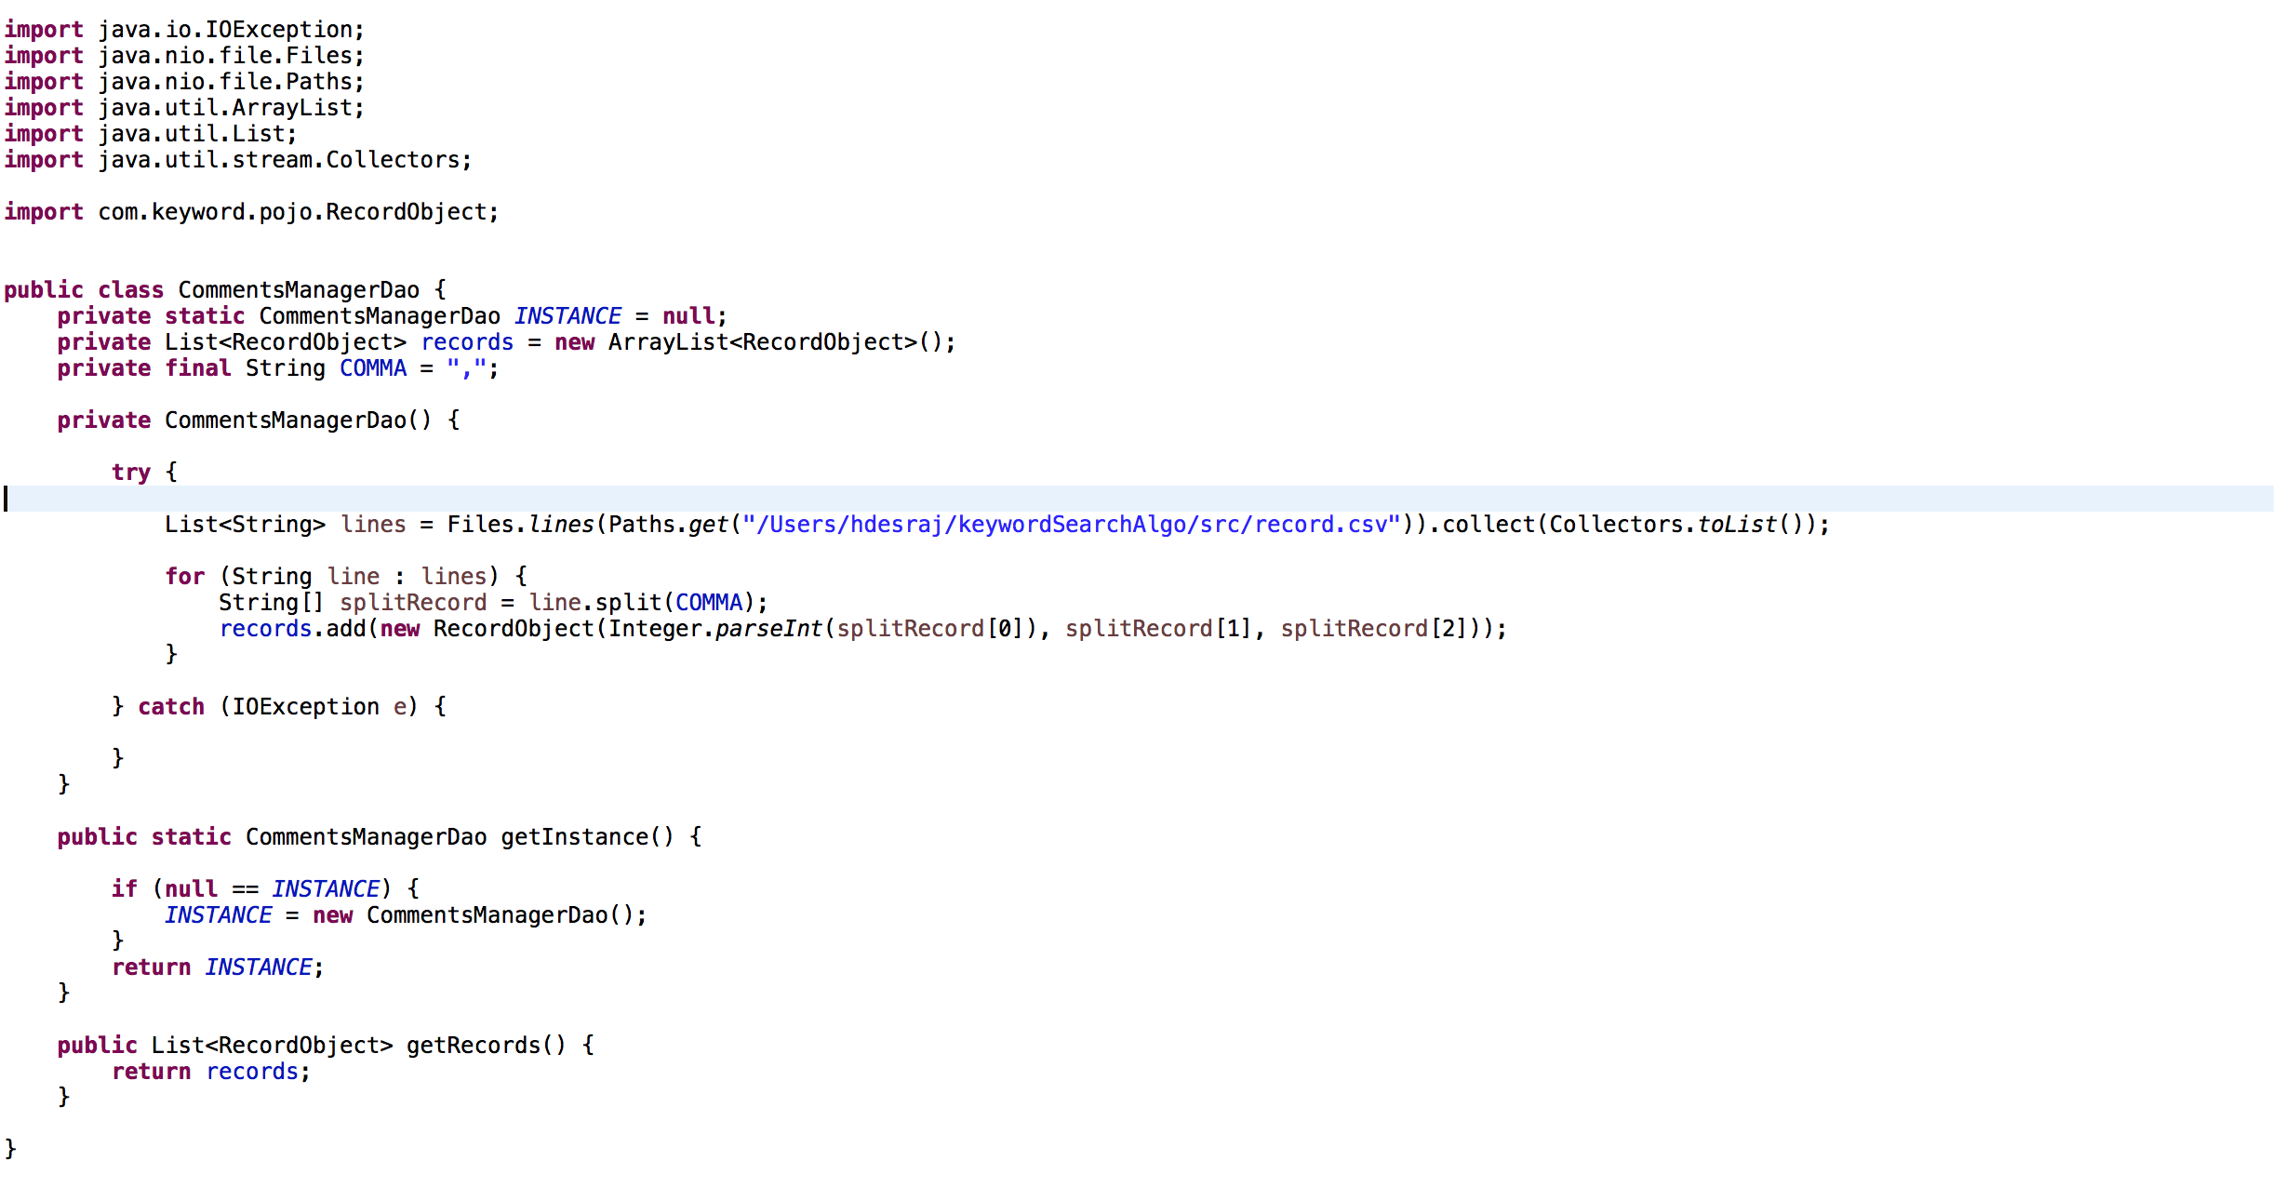

**RecordObject.java** (//Plain java object class which we use to map the Data either from csv , json.)

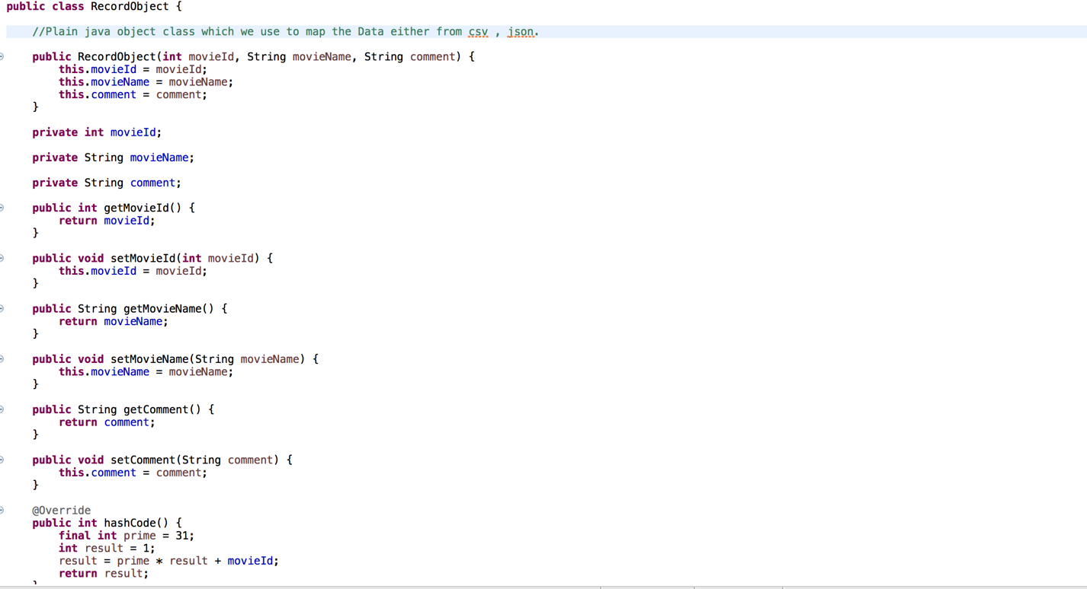

**Welcome.jsp** ( This file is used to rendered the result on UI)

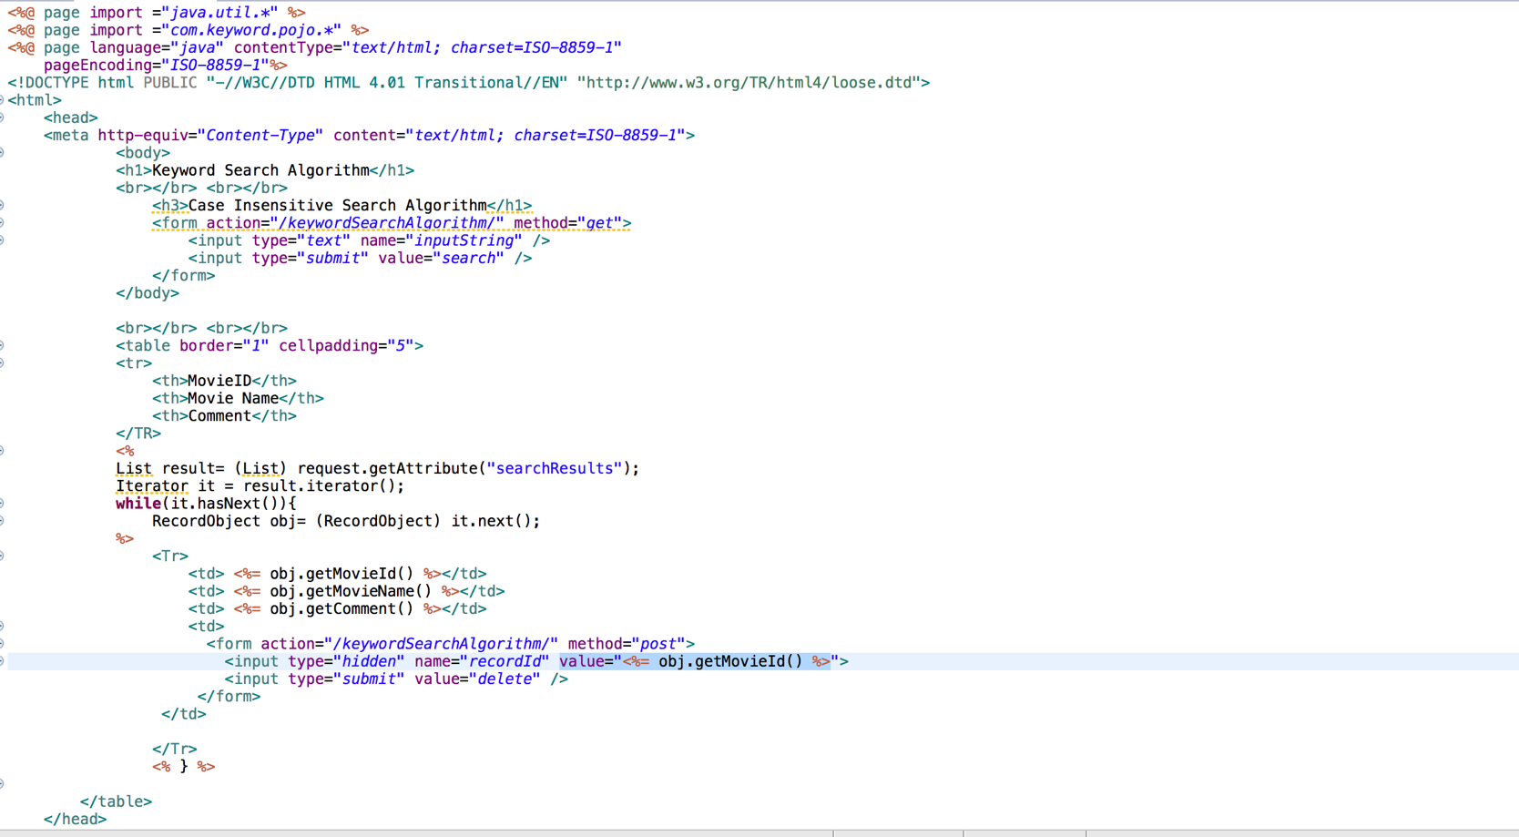

**Record.csv (**sample data to perform the required operation**)**

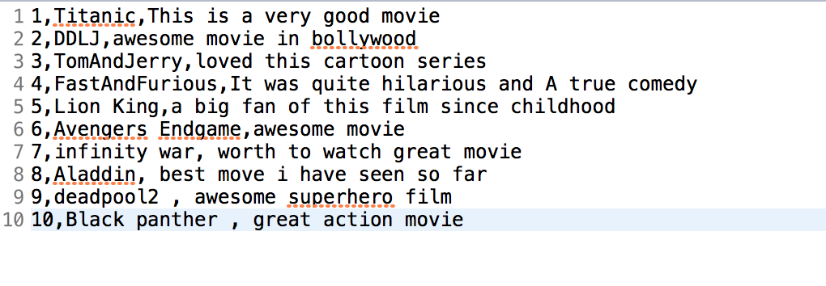

**Testing Evidence**

**Initial Data fetch from CSV**

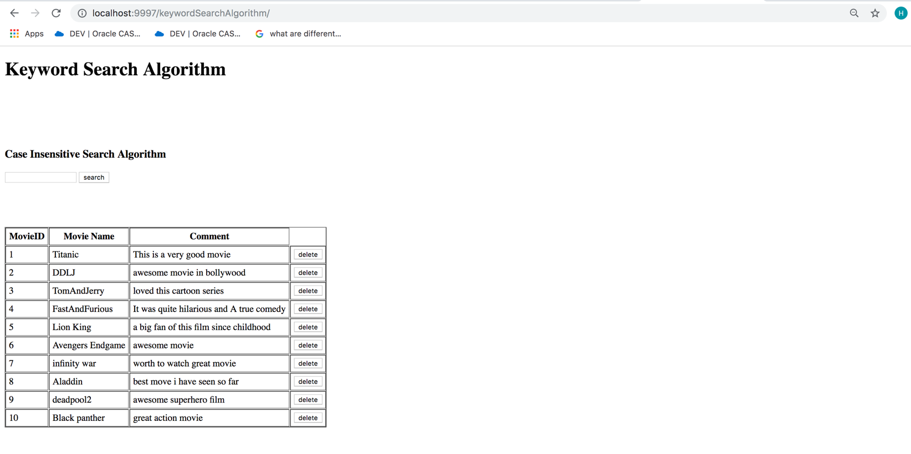

**Search Operation (input String – “awe”)**

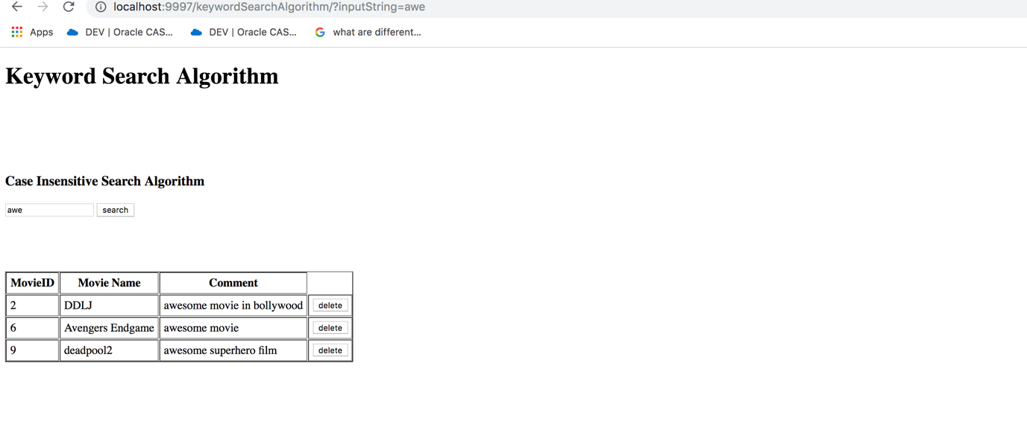

**Search Operation (input String – “ ” blank string)**

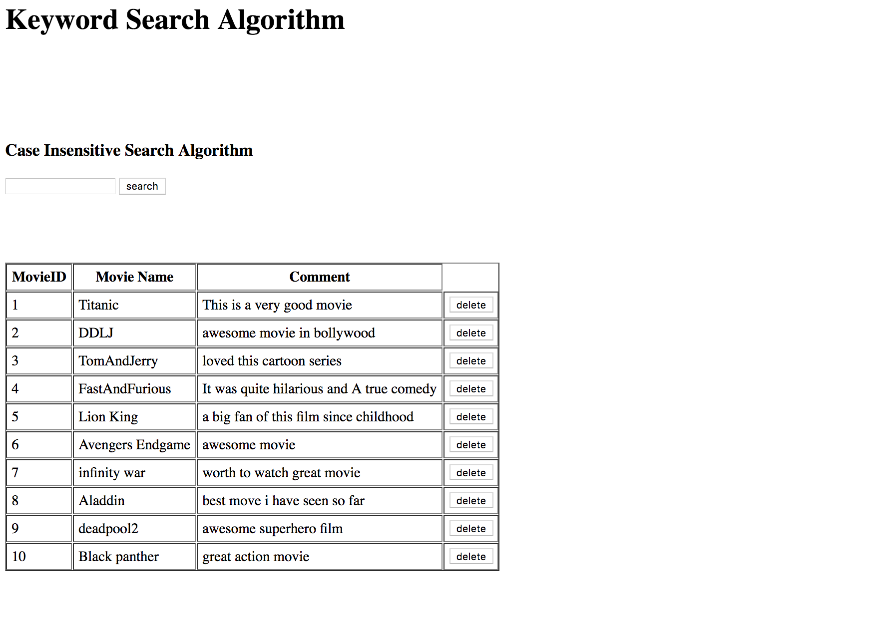

**Delete Opeation (Delete row 5)**

